Developer Environment Setup Documentation

# Operating System Installation

Steps and Screenshots of Windows 11 Installation:

1. Download Windows 11:

* Visit the official Microsoft website: [Windows 11

Download](https://www.microsoft.com/software-download/windows11).

* Download the Windows 11 Installation Assistant.
* Run the downloaded file and follow the on-screen instructions to upgrade or install Windows 11.

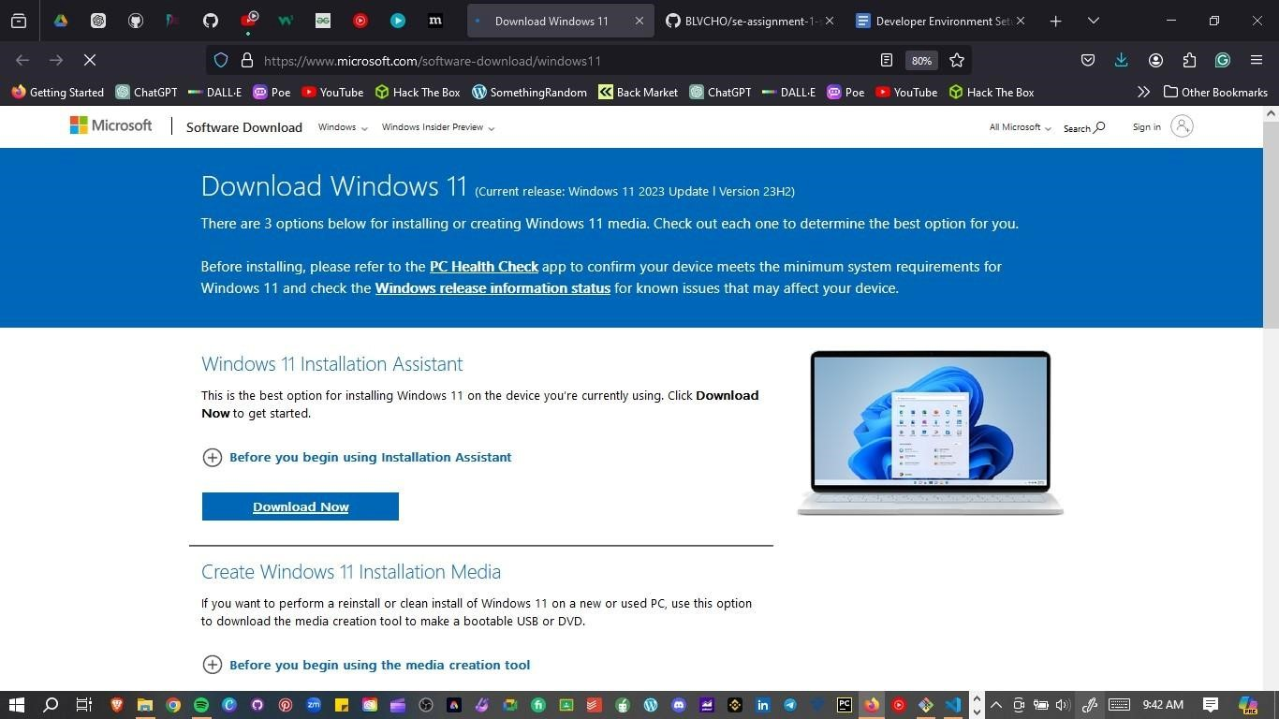

2. Installation Process:

* Ensure your PC meets the minimum system requirements.
* Back up your important files.
* Follow the installation steps, including selecting the installation type, partitioning your hard drive if necessary, and configuring initial settings.

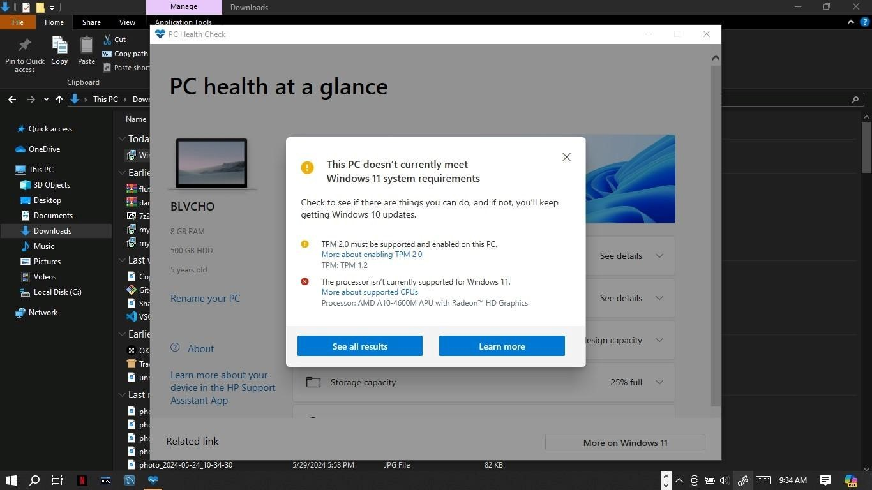

3. Post-Installation Setup:

- Configure your user account, regional settings, and privacy settings. - Install necessary drivers and updates.

NB: MY PC DOES NOT SUPPORT WINDOWS 11

# IDE Installation

Steps and Screenshots of Visual Studio Code Installation:

1. Download VS Code:

* Visit the Visual Studio Code download page: [VS Code Download](https://code.visualstudio.com/Download).
* Select the appropriate version for Windows and download the installer.

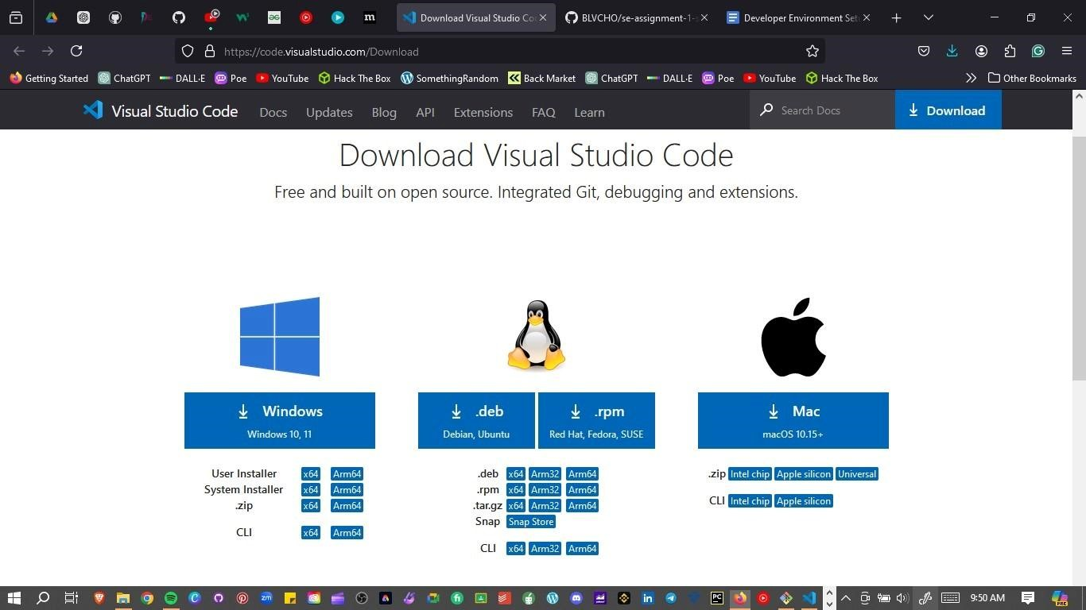

2. Installation Process:

* Run the downloaded installer.
* Follow the installation wizard, accepting the license agreement and choosing the installation location.
* Select additional tasks such as adding to PATH and creating a desktop icon.

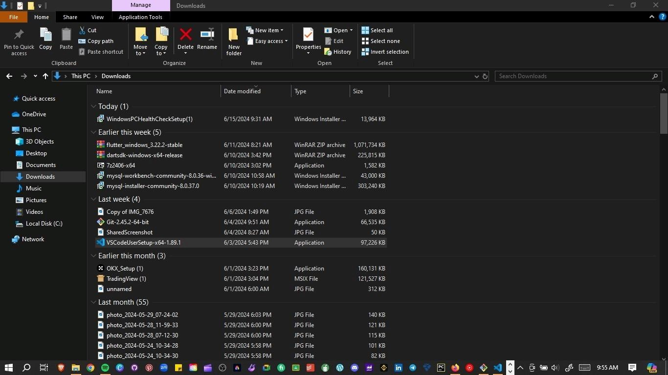

3. First Launch and Setup:

- Launch VS Code and install recommended extensions like Python, GitLens, and Docker.

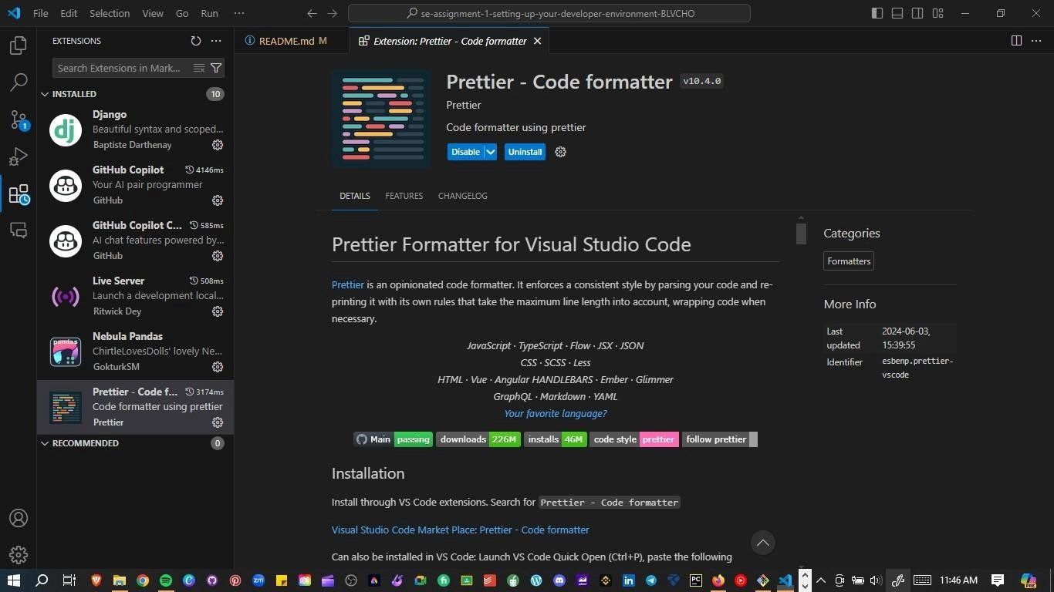

# Version Control Setup

Steps for Installing Git, Creating a GitHub Account, Initializing a Repository, and Making the First Commit:

1. Install Git:

* Download Git from the official site: [Git Download](https://git-scm.com/downloads).
* Run the installer and follow the setup instructions, choosing your preferred options for PATH, line endings, and other settings.

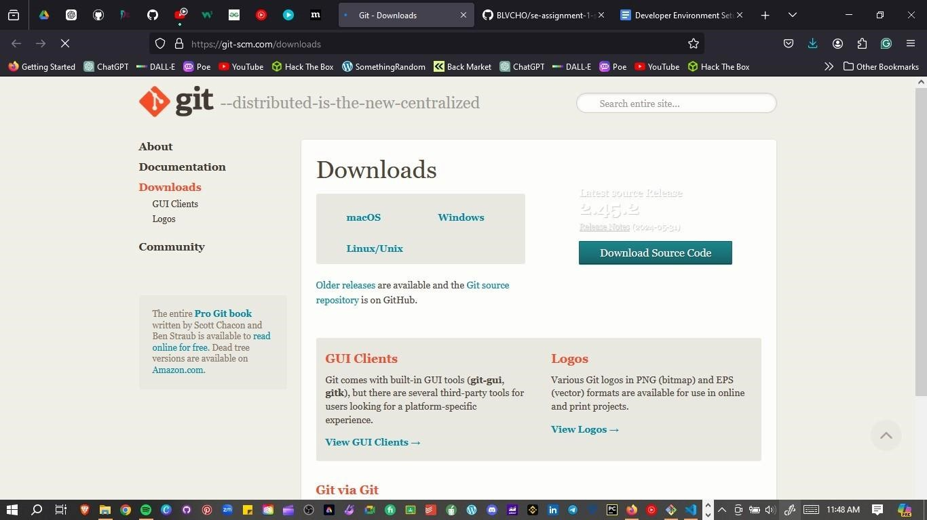

2. Create a GitHub Account:

- Visit [GitHub](https://github.com) and sign up for a new account if you still need to get one.

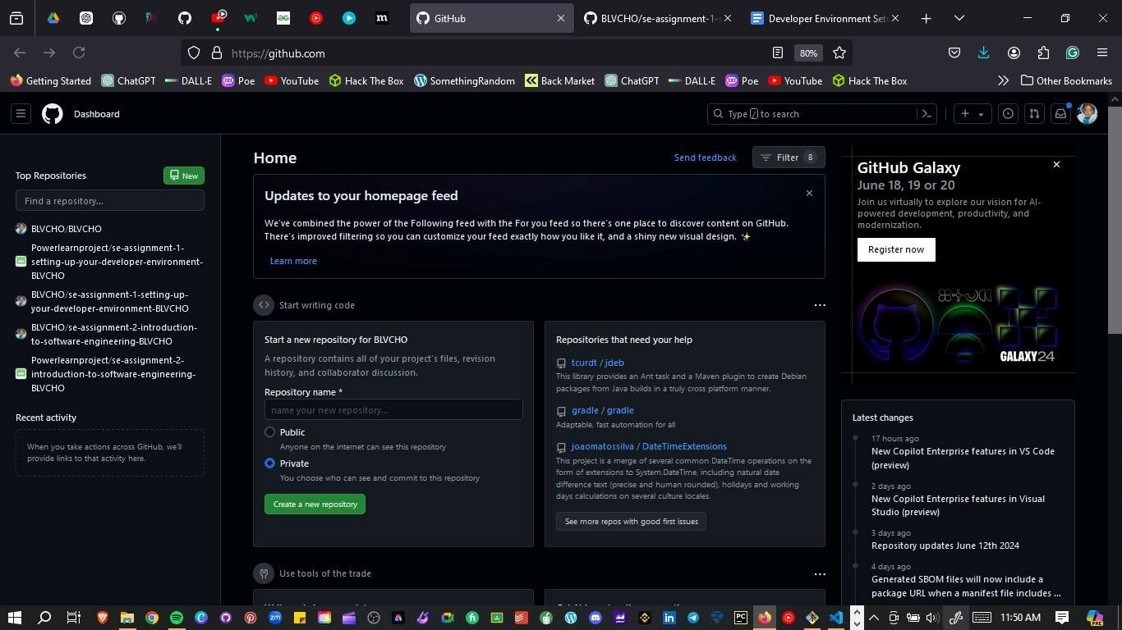

3. Initialize a Git Repository:

* Open Git Bash or the terminal in VS Code.
* Navigate to your project directory or create a new one:

```bash mkdir my_project cd my_project

```

* Initialize a Git repository: ```bash git init

```

* Create a README file:

```bash

echo "# My Project" >> README.md

```

* Add the README file to the staging area:

```bash

git add README.md

```

* Commit the changes:

```bash git commit -m "Initial commit"

```

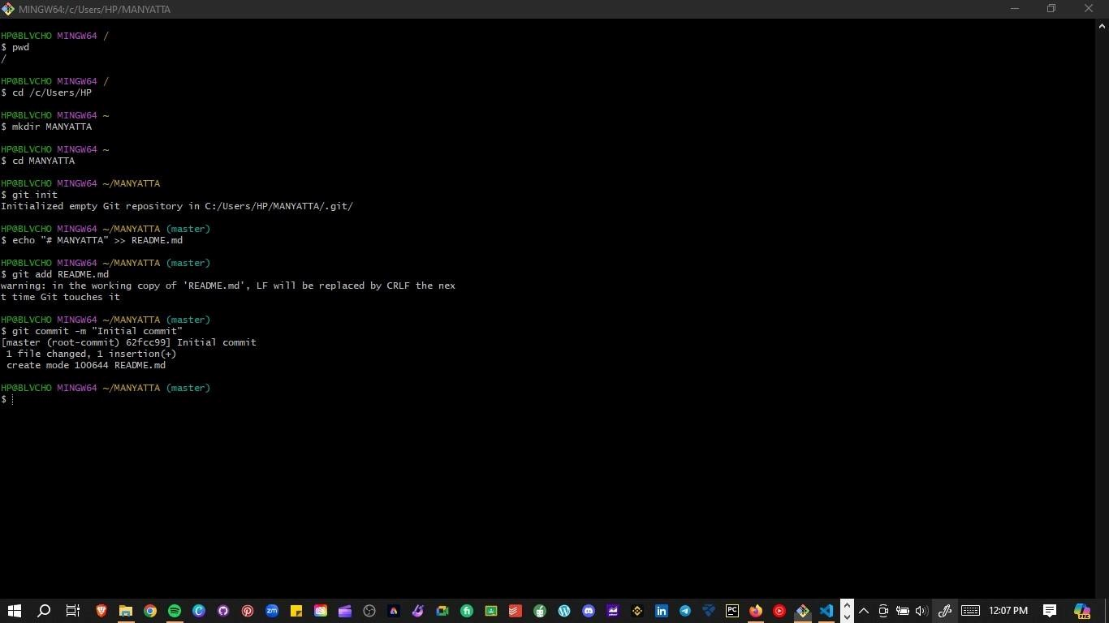

# Programming Languages and Runtimes

Steps for Installing Python:

1. Download Python:

* Visit the official Python website: [Python

Download](https://www.python.org/downloads/).

* Download the latest version of Python for Windows.

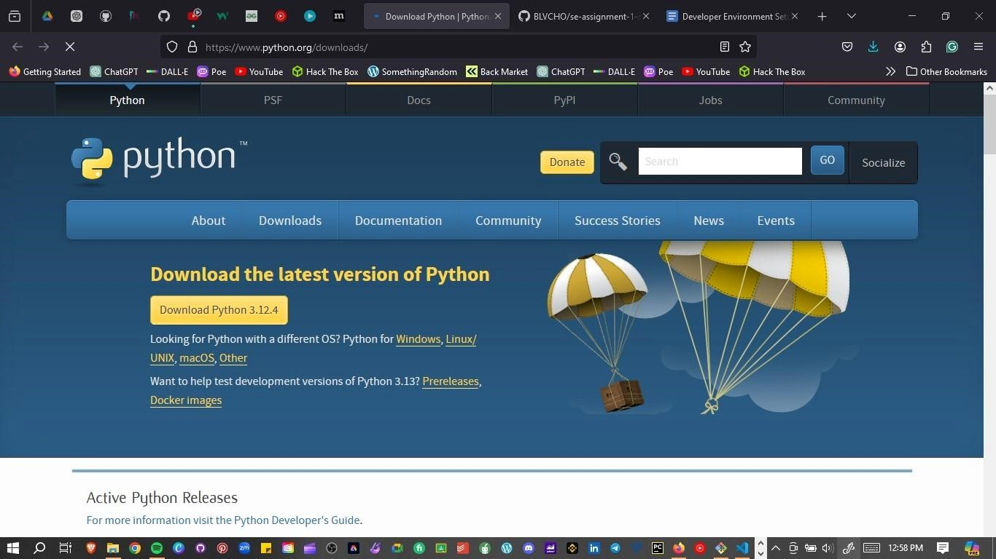

2. Installation Process:

* Run the installer, ensure you check the option to add Python to PATH.
* Follow the installation wizard.

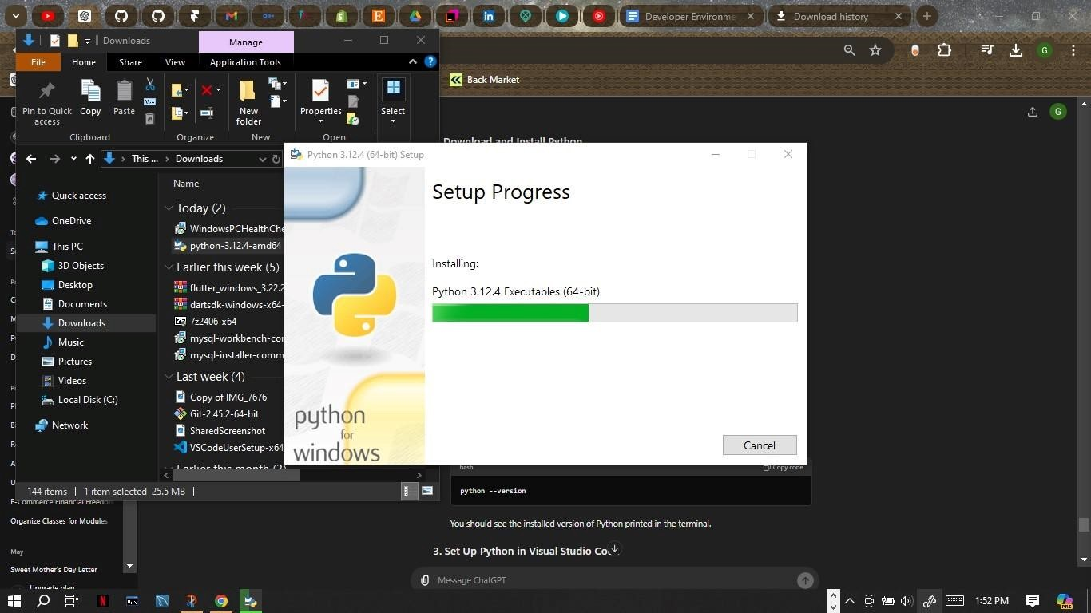

3. Verify Installation:

* Open Command Prompt and type:

```bash python --version

```

* Verify pip installation: ```bash pip --version

```

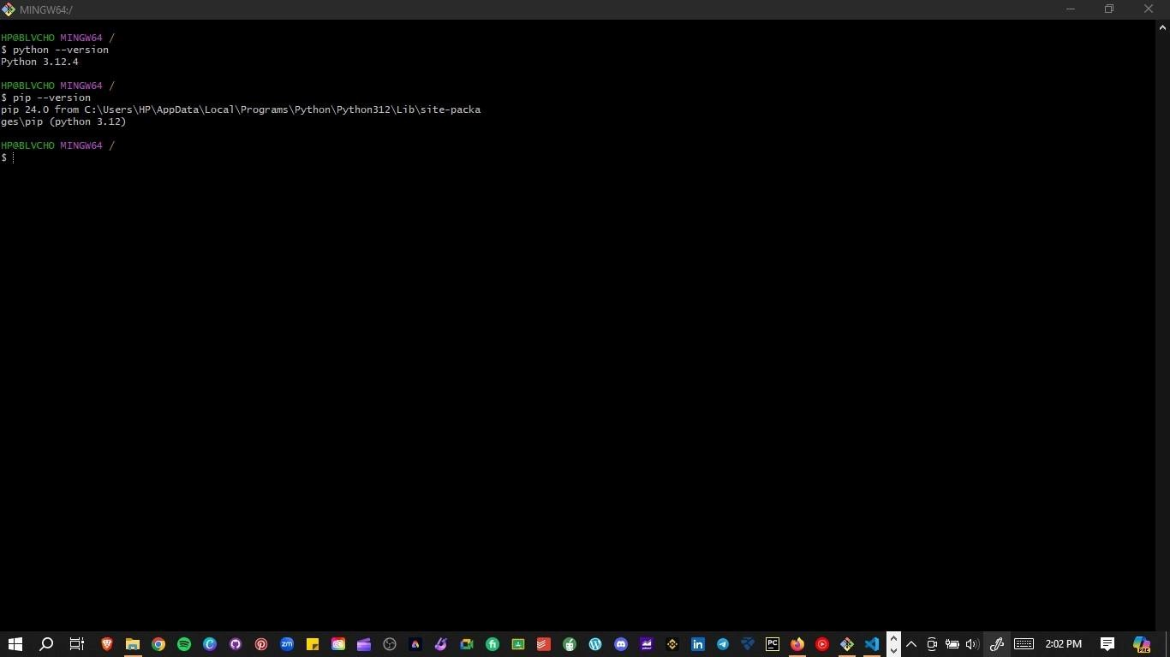

# Package Managers

Verification of pip Installation:

1. Verify pip:

- Open Command Prompt and type:

```bash pip --version

```

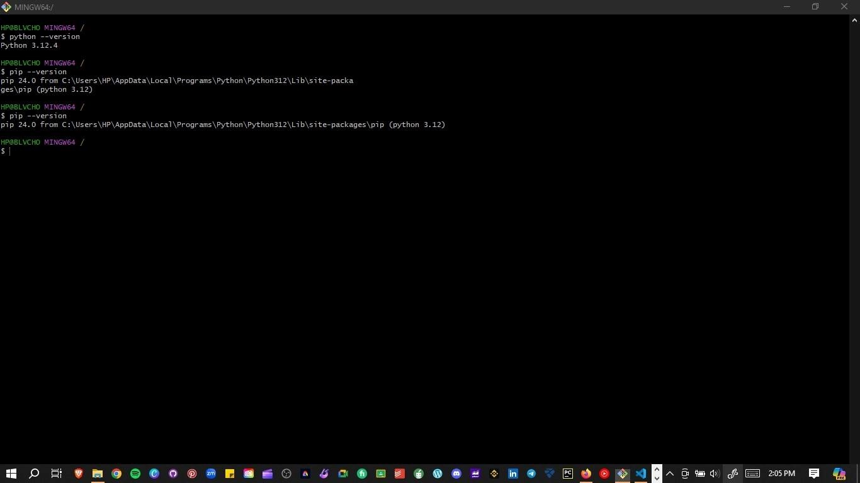

# Database Configuration

Steps for Installing MySQL:

1. Download MySQL:

* Visit the MySQL download page: [MySQL

Download](https://dev.mysql.com/downloads/windows/installer/5.7.html).

* Download the MySQL Installer for Windows.

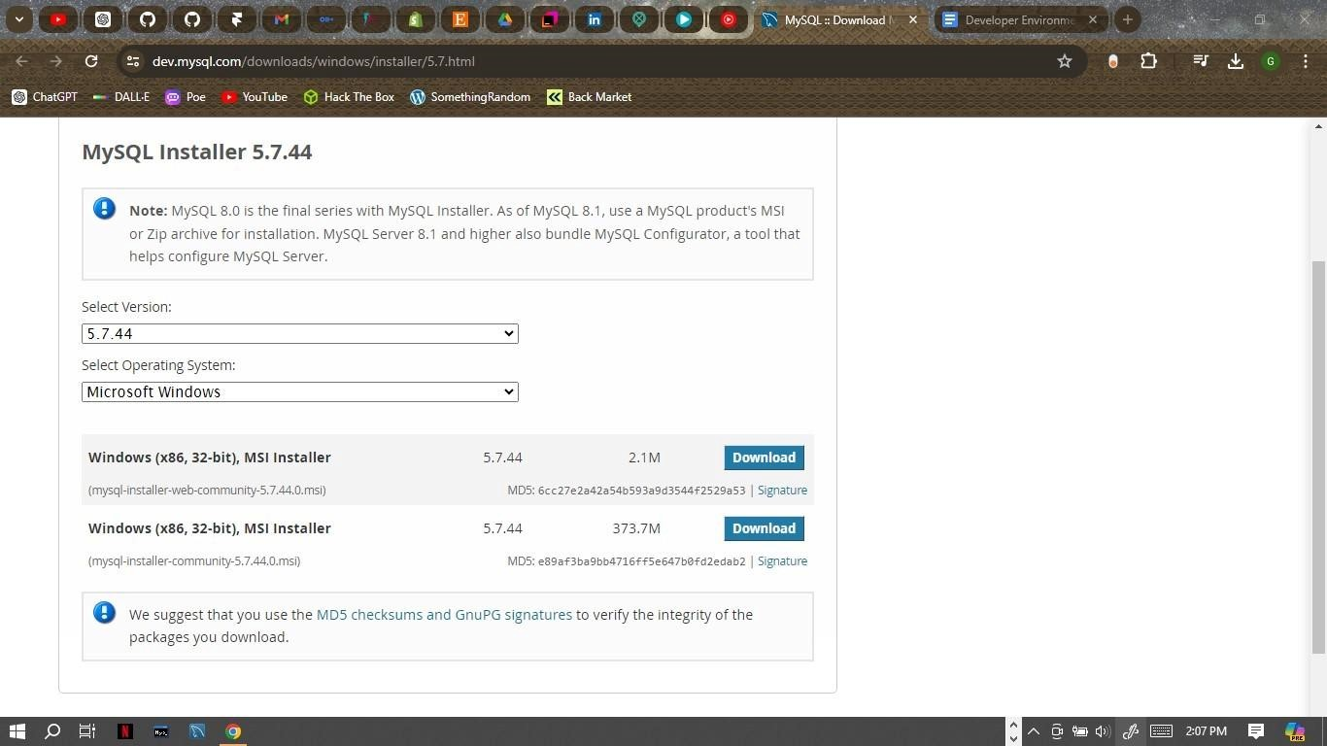

2. Installation Process:

* Run the MySQL Installer and follow the setup wizard.
* Choose the setup type (e.g., Developer Default).
* Configure MySQL Server settings, including the root password.

NB: MYSQL IS ALREADY CONFIGURED WITH PASSWORD

3. Verify Installation:

- Open MySQL Workbench or MySQL Shell and connect to your MySQL server.

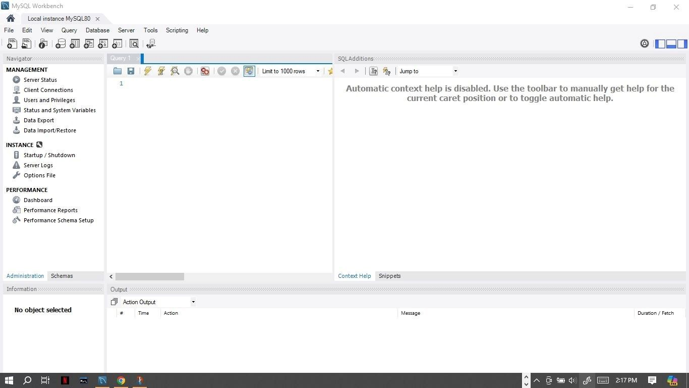

# Development Environments and Virtualization (Optional)

Optional Steps for Installing and Setting Up Docker:

1. Download Docker:

- Visit the Docker Desktop download page: [Docker Download](https://www.docker.com/products/docker-desktop). - Download and run the Docker Desktop installer. ![Docker Download](images/docker-download.png)

2. Installation Process:

* Follow the installation instructions.
* Start Docker Desktop and follow the setup wizard.

NB:NOT OPTED FOR

3. Verify Installation:

- Open Command Prompt or PowerShell and type:

```bash docker --version

```

NB:NOT OPTED FOR

# Extensions and Plugins

List of Installed Extensions for VS Code:

1. Install Extensions:

* Open VS Code.
* Go to the Extensions view (`Ctrl+Shift+X`).
* Search for and install the following extensions:
* Python
* GitLens — Git supercharged
* Docker
* Prettier - Code formatter
* ESLint
* MySQL

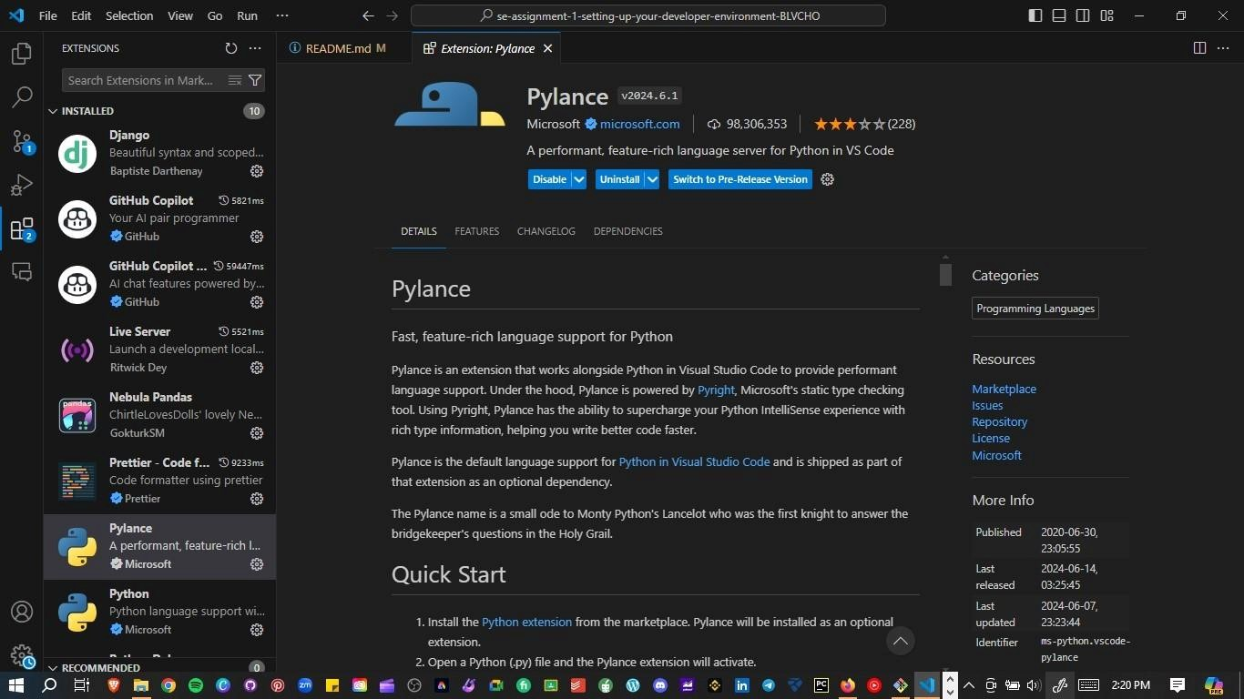

# Challenges and Solutions

1. Challenge: Installing MySQL and Configuring the Root Password

- Solution: Followed a step-by-step tutorial and used the official MySQL documentation for troubleshooting.

2. Challenge: Initializing a Git Repository and Making the First Commit

- Solution: Used Git documentation and GitHub guides to understand the commands and workflow.

# Deliverables

1. Setup Documentation:

- This document with detailed steps and screenshots.

1. GitHub Repository:<https://github.com/BLVCHO/sample-repository.git>
2. Reflection:

- Included in the Challenges and Solutions section.